Wednesday Co-ed 4’s AA Gold Bracket
BEST 2 OUT OF 3 GAMES. FIRST 2 GAMES TO 21; DECIDING GAME TO 15 - NO CAP - LOSING TEAM OFFICIATES NEXT MATCH

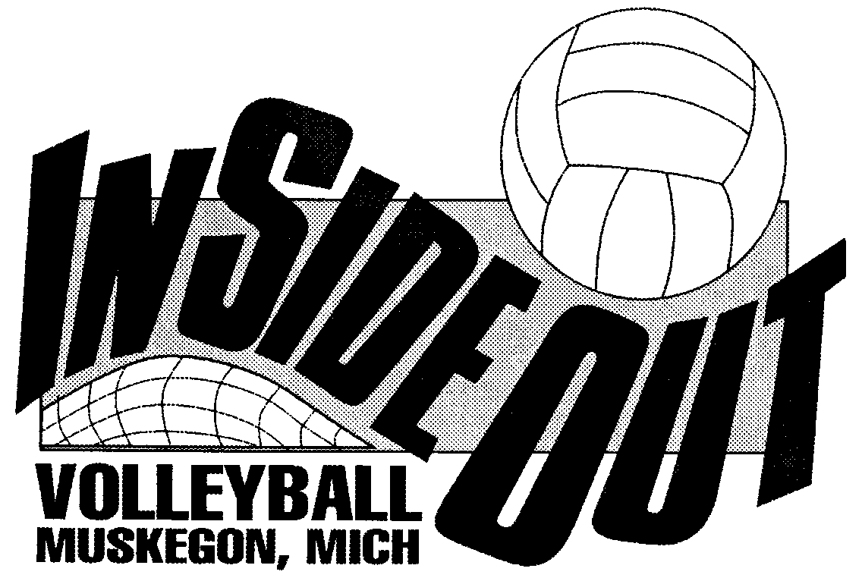
4th - Beach Slapping Cheeks
COURT 6

6:30

M
5th - Family Squad |  |  | COURT 6  7:15
 |  |  | 1st – Team Ultra
 |  |  | 2nd - Funkadelic | COURT 6  Both teams take ct down
 |  |  | 2nd - Funkadelic | COURT 6  Both teams take ct down | Champion
3rd - Hit For Brains |  |  | COURT 7  Losing team takes ct down | 8:00 | Score  __________________
COURT 7  6:30 |  |  | 7:15 |  | _________________
6th – Hot Shots |  |  |  |  | _________________
TOURNAMENT DATE August 9, 2023 DIVISION: Co-ed 4’s AA Gold Bracket

Winner’s Sweatshirt Sizes Runner’s Up T-Shirt Sizes

Team Name: ________________ Team Name: ________________
1. ________ 1. ________
2. ________ 2. ________
3. ________ 3. ________
4. ________ 4. ________
5. ________ 5. ________
6. ________ 6. ________
7. ________ 7. ________
8. ________ 8. ________

